The Kamilaroi and Euahlayi Emu in the Sky

by Robert Fuller

The concept of the Emu in the Sky exists in different Aboriginal groups across Australia. These stories have different meanings, from indicators of resources (when to collect emu eggs) to that of culture heroes. The Kamilaroi and Euahlayi peoples, who live in the north and northwest of New South Wales, also have traditions of an Emu in the Sky, which differed from many of the other accounts. For the Kamilaroi and Euahlayi, the celestial Emu represents different things at different times of the year. The Emu first becomes visible in March. When it is fully visible in the Milky Way during April and May, it assumes the form of a running emu (Figure 1). This represents a female emu chasing the males during the mating season. Because emus begin laying their eggs at this time, this appearance of the celestial Emu is a reminder that the emu eggs are available for collection.

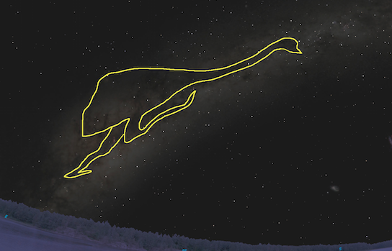
Figure 1

In June and July, the appearance of the Emu changes, as the legs disappear. The Emu, which is now male, is sitting on its nest, incubating the eggs (Figure 2). The eggs are still available for collection as a resource at this time.

Figure 2

The Kamilaroi and the Euahlayi have in common their male initiation ceremony, called the bora. The preferred time for the bora ceremony is during the summer, but the planning for the ceremonies, and possibly the layout of the bora site, may take place in August and September. There is a strong connection between the bora ceremony and the Milky Way, where the culture hero Baiame lives, and to whom the ceremony is dedicated. There is also evidence that the Emu is connected to the ceremony: as male emus rear the young, so male Aboriginal elders nurture the young initiates into manhood.

The bora ceremonial site usually consists of two circles, one large, and one small, connected by a pathway. In August and September, the Emu once again changes appearance to that of two circles in the sky, vertically aligned above the south-southwest horizon (Figure 3). This is the direction to which most bora sites are aligned (from large circle to small circle).

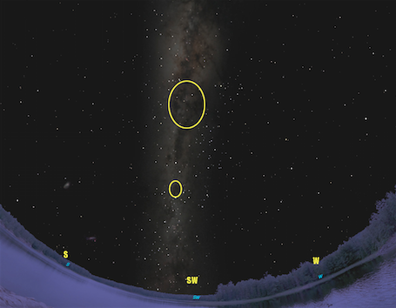
Figure 3

Later in the year, around November, the Emu once again changes appearance and becomes Gawarrgay/Gawarghoo, a featherless Emu that travels to waterholes and looks after everything that lives there. The Emu is now low on the horizon in the evening, so it appears only as the “body” of the Emu. The Kamilaroi and Euahlayi say this is because the Emu is sitting in a waterhole (Figure 4). As a consequence, the waterholes in country are full (which is often the case in November).

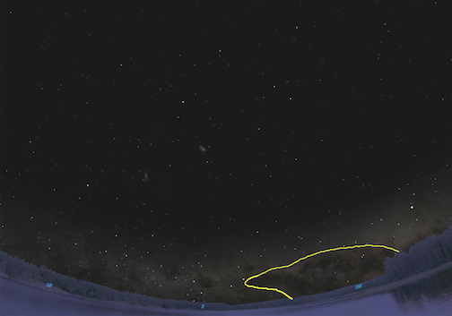
Figure 4

Later in the summer, the Milky Way and the Emu dip below the horizon. This signifies that the Emu has left the waterholes, which dries up the waterholes.

The Kamilaroi and Euahlayi peoples have a complete story of the Emu in the Sky, and this reflects their belief that, at one time, the sky and everything in it was “down here”, and what is now “down here” was in the sky. This explains the connection between the Emu in the Sky, and the emu bird on the ground, and the connections to resource management and the ceremonial aspects of the male initiation ceremony.

